Intermediate – Group I
Accounting (New Syllabus)Pendrive Details
Sr.No | Particulars | Details
1. | Pendrive Charges | 14,000/-  ( incl. GST)
2. | Actual Duration 106 Lectures of 02:10 hrs. Approx.
3. | Total viewing Hours allowed is 2 times. It means, you can view each lecture for 2 times of its original recorded duration. | Each lecture 2 times to see
4. | Validity Period [ From the date of registration ] | 1 Year
5. | Mode of Delivery | 64 GB – 2 Pen drives
6. | Language used while teaching ( Mixture of ) | Hindi + English
7. | Product Expiry : Each Lecture will expire after 2 times of viewing hours or 50 clicks or 1 year from registration, whichever is earlier.
8. | After the expiry of product, you can format the pen drives and use it for storage purpose
9. | Following are the details for making Payment :  RTGS Details –  Account Name :Mrs. Joshi’s Accounting Academy  Bank Name : Axis Bank Ltd., Sadashiv Peth Pune Branch  Account No. : 911020033580998  IFSC Code : UTIB0001437  Amount Rs. : 14,000/-( incl. GST)

10. Printed Study Material:
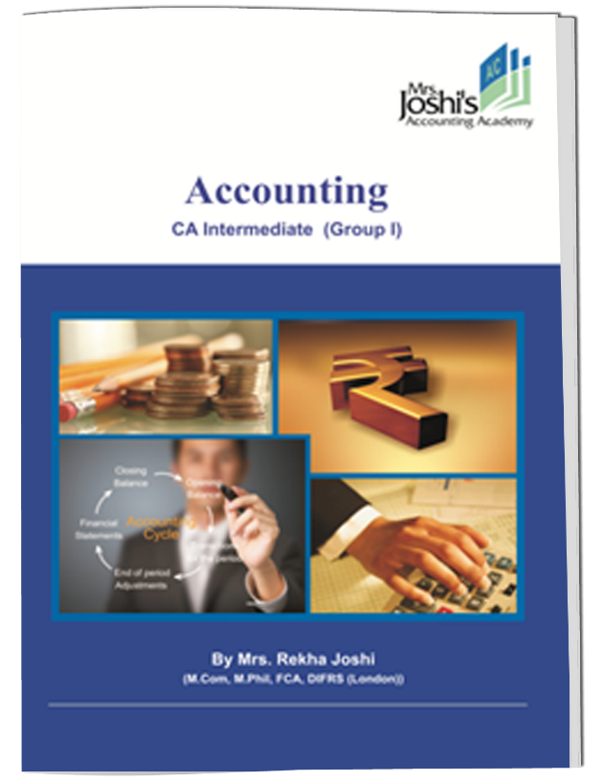
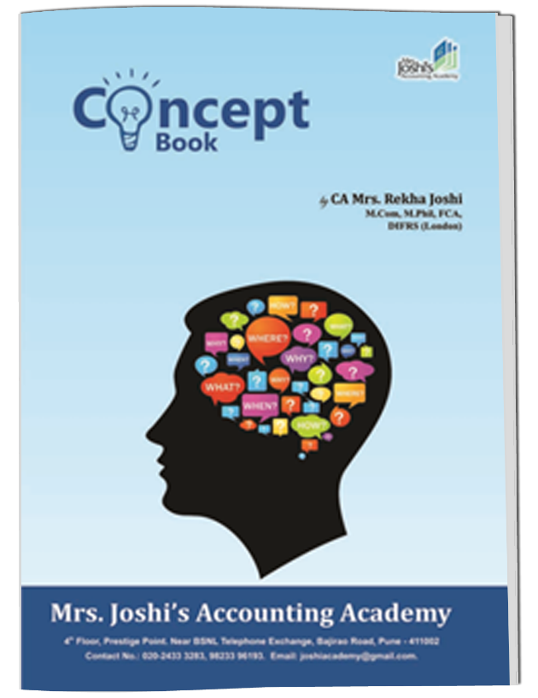
AS
Home Exercises
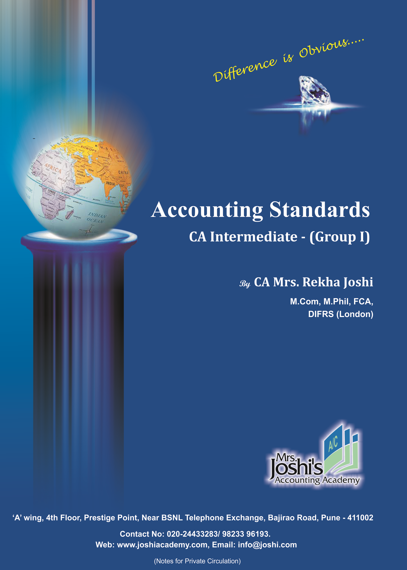
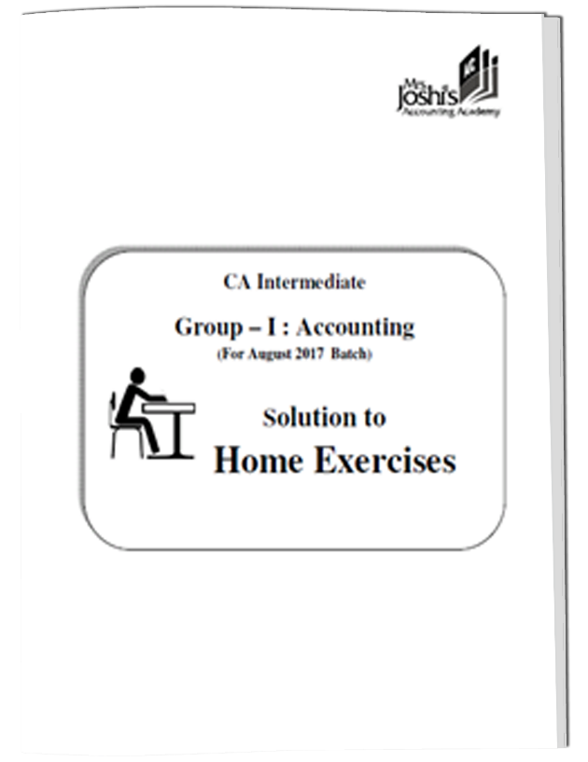
Concept Book

Regular Notes

Intermediate – Group II
Advance Accounting (New Syllabus)Pendrive Details
Sr.No | Particulars | Details
1. | Pendrive Charges | 13,000/-  ( incl. GST)
2. | Actual Duration 65 Lectures of 02:10 hrs. Approx.
3. | Total viewing Hours allowed is 2 times. It means, you can view each lecture for 2 times of its original recorded duration. | Each lecture 2 times to see
4. | Validity Period [ From the date of registration ] | 1 Year
5. | Mode of Delivery | 64 GB – 2 Pen drives
6. | Language used while teaching ( Mixture of ) | Hindi + English
7. | Product Expiry : Each Lecture will expire after 2 times of viewing hours or 50 clicks or 1 year from registration, whichever is earlier.
8. | After the expiry of product, you can format the pen drives and use it for storage purpose
9. | Following are the details for making Payment :  RTGS Details –  Account Name :Mrs. Joshi’s Accounting Academy  Bank Name : Axis Bank Ltd., Sadashiv Peth Pune Branch  Account No. : 911020033580998  IFSC Code : UTIB0001437  Amount Rs. : 13,000/- ( incl. GST)

10. Printed Study Material:
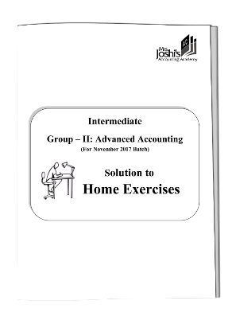
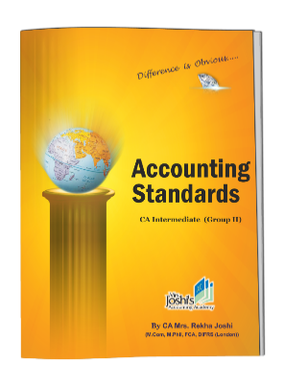
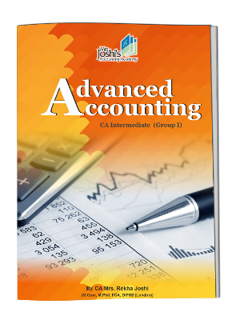
Home Exercises
AS
Concept Book
Regular Notes

